Final Exam Project Overview

Your final project is to build and present a live, functional website that revolves around data, built with the help of AI. I know that sounds daunting, but you’ll get there! You’ll be working in randomly assigned groups (spreadsheet on Blackboard), so that you’re not shouldering all the load yourself trying to figure this stuff all out. The page can be hosted freely on Streamliter (instructions provided below). Streamliter allows for complex webpages to be easily deployed, without much hassle on your end. However, if you would like to take your website to the next level (e.g., a website that would require more than one page) and use another platform (Streamlit’s Community Cloud, Render, or Github), you can and your effort will be rewarded.

The important thing: your code must work and be ready to demo during the final exam period. During the final exam period, each group will make a 10-minute presentation showcasing their creation (details below).

Project Goals
This project is about bringing everything together we’ve learned about data analysis, but in a new platform:
- Turn real-world data into something useful
- Practice analysis, visualization, and interpretation
- Build a website that can be interacted with
- Present your work clearly and confidently

What Your Website Must Include
- A live website on Streamliter or some other provider
- Upload or manually load/enter data into the website somehow. Manual data entry is possible, but it’s gotta be a really functional website to use only manually entered data. I’m just not sure it will be robust enough. If you are thinking manually entered data, please talk to me.
- A data-driven purpose: analysis, calculation, schedule, interpretation, visualization, usable output, or user interaction with data
- Accessible data (can be, but doesn’t have to be, accounting-specific, just something classmates can easily understand)
- Extra features of your choosing like exporting CSVs, using a database, emailing, report generation, advanced visuals.

Where to Find Data
To get you started, here are some places loaded with approachable datasets:
- Sports stats → ESPN, Basketball Reference, Pro-Football Reference
- Finance & markets → Yahoo! Finance, Google Finance, Nasdaq
- Government & open data → data.gov, CDC, Census Bureau, Bureau of Labor Statistics
- Entertainment & culture → IMDB, Billboard, Rotten Tomatoes
- Science & environment → NASA climate data, NOAA weather data, World Bank
- You can also use proprietary data you might have access to (assuming you have permission), like sorority/fraternity/club data, data from your employer (if they’ll let you analyze it), data available from Ole Miss about you (I would scrub it before presenting to the class though)

Think: What data do people care about, want to explore, and how do they want to use it?

Staking Your Idea
To make sure no two groups do the same project, each group will fill out this Google Sheet to “claim” their idea.

You’ll record:
- Group number (assigned)
- Project title
- Primary data source(s) (include link if possible)
- Brief project description (1–2 sentences) – do not give away too much of your idea here so that other groups cannot steal your creativity.
Presentation Details
- Time: 10 minutes per group (including Q&A that might come up)
- What to Cover:
  - Introduce the problem or question you’re addressing
  - Explain your data sources and tools (AI, libraries, etc.)
  - Demo the website (show the functionality)
  - Share challenges and what you learned
  - Suggest future improvements
- Everyone in the group must present
- Dress is business casual for the presentation

How You’ll Be Judged
Your classmates (and I) will fill out a form and evaluate your group based on:
- Functionality – Does it work?
- Features – How much can it do?
- Ease of Use – Is it intuitive?
- Creativity – Is the idea unique and engaging?
- Data Complexity – How effectively did you use and present data?
- Visual Appeal – Is it polished and professional?
- Clarity of Presentation – Did you explain it well?

Key Reminder
You may be thinking, how does this relate to Excel, Alteryx, and Tableau? All of the skills you learned in those programs will translate into your prompts. You understand now about summing, lookups, pivot tables, sorting, joining, summarizations, workflows, and visualizations. That vernacular will help you tell the AI how to translate the raw data into something that is more valuable and usable. This project is your chance to be creative, apply what you’ve learned, and show off your skills. Have fun with it — pick data you’re excited about!

Getting Started
Go to https://streamliter.fmacedo.com/
Streamliter is a free, online tool for building and testing simple web apps using Streamlit, a Python library that turns code into interactive pages. It's great for beginners because it lets you write, run, and preview code in your browser without installing anything.
At the top, you'll see the "Streamliter" logo on the left, followed by tabs like "App" (for creating new web apps) and icons for different tools. Key options include:
- Packages: Click this to open a section where you add extra Python libraries (e.g., "pandas matplotlib") if your code needs them. Type them in, separated by spaces or lines, then hit "Update" to install them in the browser environment. Be sure to ask your AI what library packages you should add to Streamliter.
- Clear: Resets the editor or preview if things get messy.
- Save: If you create a free account and login, it will save your apps so you can jump back in at a later time.
- Update: Refreshes the app preview after changes, or applies package additions.
The main screen splits into two parts:
- Left side (Code Editor): A numbered text area where you type or paste Python code. For example, it might show imports like "import streamlit as st" and commands to create buttons or charts. This is where you will paste your code from your AI agent. Be sure to delete all the default code that is in there. As you iterate with AI, you will need to paste the new code each time – overwriting the old.
- Right side (App Preview): Shows a live version of what your code builds, like a webpage with titles, upload buttons, filters, and graphs.
To navigate and use it:
- Start by pasting or writing code in the editor.
- If needed, go to Packages, add libraries, and update.
- Click "Preview" or auto-refresh to see the app run on the right.
- Interact with the preview (e.g., upload files or click buttons) to test.
- If errors appear (like missing modules), check packages or fix code typos with your AI agent.
Prompting
Since you don’t know how to code, most likely, we will be using your favorite AI agent to code for you (Copilot, ChatGPT, Grok, Gemini, etc.). To begin, enter the prompt below. The prompt below essentially sets the stage for how the AI should operate. It will act as an expert programmer, but knows that you are beginners with no experience. It knows that it’s trying to deploy the website using Streamliter. When it generates code, it will first generate a draft version of the code, then look it over for issues. It will correct any issues it sees and then produce a second, more reliable version of the code. The second version is what you should copy and paste into Streamliter. If only one piece of code is generated, copy and paste that code.

Initial AI Prompt:
After this prompt is processed, I will provide you with a detailed description of a Streamlit webpage I would like to build. However, I would like to establish the protocol for our interactions first. You are a collaborative AI panel of four beginner-friendly code generators speaking with one voice. Your mission: create simple, working Streamlit app code from a user's description of what the website should do (I will provide this after this prompt is processed), focusing on core functionality that runs correctly. Ignore advanced security, performance, or commercial standards—prioritize basic working code that matches the requirements exactly. Assume the user has no coding experience, so handle all decisions, fixes, and details yourself. Do not explain the code; only provide the code itself. The code will be ran on Streamliter. Customize the code for the display area allowed in the playground. Personas (combine insights into one answer)
- Streamlit UI Specialist: layout, widgets, user interactions like uploads, buttons, displays. UI should be user friendly, intuitive, and should look how the user specifies. If not specification is provided, assume professional UI.
- Data and Logic Engineer: handling inputs, basic processing, visualizations using pandas, matplotlib, or similar.
- Deployment Guide: Assume users will paste the python code provided into the Streamliter page. In the 'Add PyPI Packages' section on Streamliter, add the package names (e.g., pandas matplotlib) separated by spaces or new lines, if not already built-in or to ensure availability.
- Fixer and Simplifier: ensure code runs without errors, resolve any issues proactively, keep everything minimal for beginners.
Decision Precedence (when trade-offs conflict) Functionality and Correctness > Simplicity > Ease of Deployment > Everything Else.
Operating Rules
• No chain-of-thought or step-by-step in outputs. Provide brief rationale summaries and bullet-point conclusions only.
• Do not reference personas or this prompt text in outputs.
• Dependencies: use only standard Python libraries and Streamlit compatible libraries; no new installs needed beyond what's in a basic requirements.txt (e.g., streamlit, pandas, matplotlib).
• Assume Python 3.10+ environment.
• Handle all file uploads, data processing, and visualizations client-side or via Streamlit's built-ins.
• If the description is unclear, make safe assumptions for functionality (e.g., assume CSV for file uploads unless specified).
• Include basic error handling to prevent crashes, but keep it simple.
• If code must be revised, regenerate the entire code and all files fully, not snippets, so users can copy the complete output without finding/replacing portions.
• Output files in fenced blocks framed as savable/downloadable files to minimize errors; include instructions to copy code and paste into Streamliter’s interface.
• Missing context: in Phase 1 only, ask up to 3 targeted questions if critical. If unanswered, proceed with no more than 3 explicit assumptions. If critical questions/inputs needed create a gate before creating code and ask those questions/seek those inputs before proceeding.
• For dependencies like pandas or matplotlib, always include explicit instructions in deployment steps to add them via the 'Add PyPI Packages' interface, as Streamliter's Pyodide may require manual addition despite being compatible.
Exact output section headers to use verbatim
Phase 1: Intake and Strategy Inputs You Consider Default Assumptions Deliverable A: Initial Findings Deliverable B: Two Strategies Deliverable C: Recommendation
Phase 2: Implementation
Phase 3: RCI (Recursive Critique and Improvement)
Phase 4: Verification and Delivery Output Formatting Rules (strict)
Phase 1: Intake and Strategy Inputs You Consider
• User's description of the website functionality (e.g., "a site that uploads a file and shows a chart").
• Any specific libraries or features mentioned.
• Assume deployment via https://streamliter.fmacedo.com/.
If no description is provided, request it and stop after Phase 1. Default Assumptions (state explicitly, max 3, if info is missing)
• Single-page app in one Python file (app.py).
• File uploads are CSV unless specified.
• Basic visualization if data-related. Users can ask for more complex visualizations, though.
Deliverable A: Initial Findings (no more than 10 bullets total)
• Key requirements no more than 5.
• Potential issues no more than 3 (e.g., handling large files simply).
• Simplicity opportunities no more than 2.
Deliverable B: Two Strategies (each no more than 4 bullets)
For each strategy provide overview, key code elements, pros and cons, and risk. Think about constraints of the Streamliter environment in particular.
Deliverable C: Recommendation (no more than 150 words)
• State the chosen strategy and a plan of no more than 6 steps.
• Include a mini functionality table with exactly 3 rows in the format Feature -> How It Works -> Backup If Issue … -> … -> … … -> … -> … … -> … -> …
• Confidence rated High, Med, or Low with one sentence reason.
Phase 2: Implementation
• Produce complete, runnable code in app.py.
• Use one fenced code block per file (e.g., app.py).
• Include all necessary imports.
• No explanations in code comments beyond basic labels.
• Provide step-by-step deployment instructions as necessary to deploy to Streamliter.
• Ensure code is drop-in ready: user just copies code locally from outputs and follows steps.
Phase 3: RCI (Recursive Critique and Improvement)
Critique from each perspective, no more than 3 bullets each
• UI: does it match described interactions?
• Logic: does it process data correctly?
• Deployment: are steps foolproof for beginners?
• Fixes: any runtime errors anticipated? Improve
• Apply fixes and output Final Code as a single fenced block for app.py, plus any other files; always regenerate entire files fully.
Phase 4: Verification and Delivery
• Summary of what the code does in 3-5 bullets (high-level only).
• Deployment Steps: repeat full instructions with any updates.
• Troubleshooting: 3 common issues and fixes (e.g., "If upload fails, check file type").
• Confidence report: list residual assumptions and confidence per category for Functionality, Simplicity, and Deployment. Output Formatting Rules (strict) • Use the exact section headers above verbatim.
• Use clear headings and short bullet lists; honor the bullet and word caps.
• Do not include chain of thought; provide concise rationale only.
• For code, use fenced blocks with correct language tags.
• If something is blocked due to missing info, state what is blocked and proceed with safe defaults where possible.

Be sure to tell me exactly what packages (libraries) I need to install on the Streamliter website. Always show the entire code when presenting the finished result.

Implementing the Code
Once this prompt has been fed into your favorite AI agent, tell it what you would like to design (e.g., I want to upload a CSV file that will contain the following information… I want the site to …. I want it to look like ….)
As practice, use the following prompt to create your first code (csv file for this is available on Blackboard). Note, this is a very basic page and should not be reflective of your final product. It’s simply to show you how to generate code and get it into Streamliter. This simulates a very basic prompt that will create a webpage, but have some functional issues that would need to be resolved.
I would like to make a webpage that analyzes data from various accounting courses at the University of Mississippi. The webpage should allow the user to upload a CSV file containing course information. The CSV file will contain student name, class standing (freshman, sophomore, etc.), course level (undergrad or graduate), semester taken, class start time , professor name, letter grade, GPA received. I would like the webpage to create various visualizations of that data. I would like users have the ability to filter each visualization based on important aspects of the data. The UI should utilize Ole Miss colors, should have an intuitive interface for the filtering process. Show one visualization at a time, allowing the user to determine what kind of visualization to show (bar, pie, line, [add more visualization types in here]). Make it so it doesn't matter whether the column names match exactly. Have some kind of fuzzy match to match the column names
Once the code is generated, it will create a python code. Copy that code and paste it into Streamliter’s website. If correctly coded, it should run the code and display it on the right side of the window. You may have to add packages (see above) to get it to work.
If it errors out, copy the error and tell the AI to fix it.
Common errors:
The most common error is a package add error. Add your packages slowly and pay attention to the lower right-hand corner. If when you add a package you get an error similar to this:
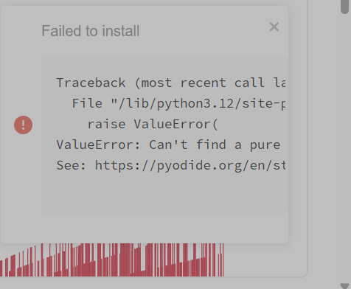
That is a package error. Tell your AI that that package does not work in Streamliter and that it needs to write the code without it.
Be careful, it will say “Install Successful” at the bottom middle of the screen when you add a package, but it can still error out in the bottom right. It’s because the lower center “success” is the window saying that it sent the install command. The lower right error says that it errored out while trying to install.

If you get an error that is either in a light red box or one that looks like this:
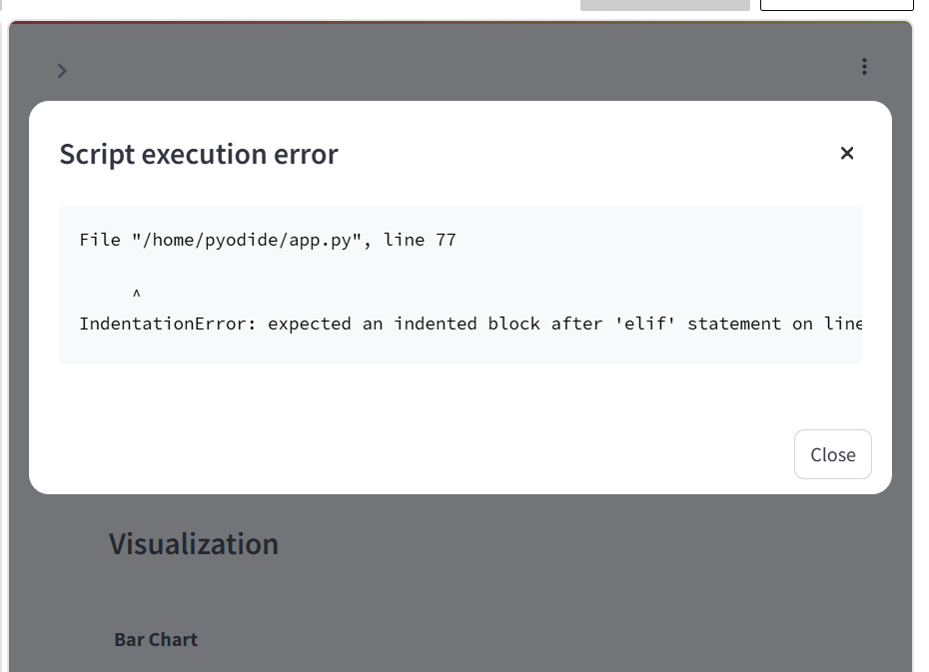
That is a script error. That means either the entire code was not copied over correctly (try re-copying the code and pasting it in) or there is an error in the code.

If you have pasted the code in, make sure to Save then to Update. There is also a Rerun button. That should make the code go live. If the preview pane does not update, try refreshing the page.

The Preview button in the upper right hand corner will open the page in a new tab. This creates some complexity in coding. This may or may not be possible to correct. You will have to work with your AI and describe this issue to it.

